Pure as Ice Anti-Doping Education Programs
at the Junior World Championships 2025/26

ISU Junior World Figure Skating Championships 2026 – Anti-Doping Education

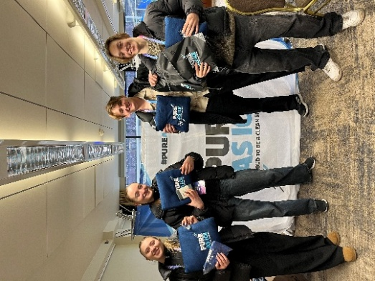
During the 2026 ISU World Junior Figure Skating Championships in Tallinn, Estonia, the ITA on behalf of the ISU delivered on-site anti-doping education activities aimed at promoting clean sport among young athletes and their support personnel.
Over two days, an interactive education booth engaged approximately 40–50 participants from around 18 countries, primarily athletes aged 13–22. The initiative focused on raising awareness of Anti-Doping Rule Violations (ADRVs), athletes’ rights and responsibilities, the Prohibited List, and safe decision-making regarding medications and supplements.

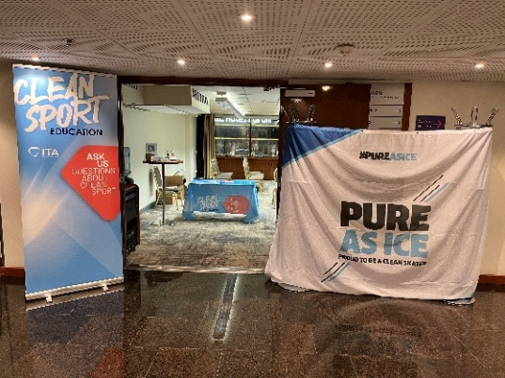
Participants showed strong prior knowledge, with many already familiar with the ISU’s Pure as Ice programme and other anti-doping initiatives. Interactive activities such as quizzes and games proved particularly effective in engaging younger athletes and reinforcing key messages.
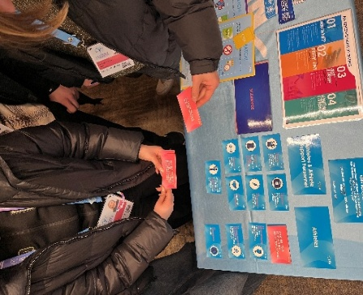

The campaign achieved an overall success rating of 8/10 according to ITA’s own metrics, highlighting its effectiveness in raising awareness and providing accessible education in a dynamic competition environment.

ISU Junior World Synchronized Skating Championships 2026 – Anti-Doping Education

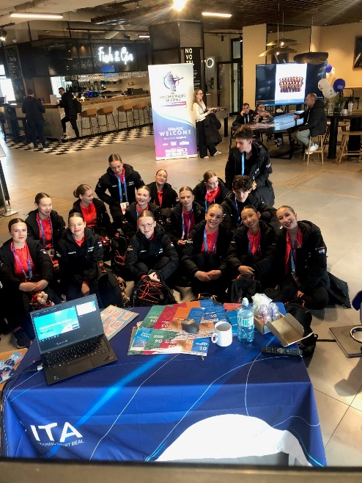
At the 2026 ISU World Junior Synchronized Skating Championships in Gdansk, Poland, the ISU and ITA, through one of ITA’s Education Ambassadors delivered a full-day, on-site anti-doping education workshop tailored to young, synchronized skating teams.
The workshop reached approximately 70–80 athletes from 6 countries, offering in-depth sessions on clean sport principles, ADRVs, the doping control process, and informed decision-making around supplements and medications.

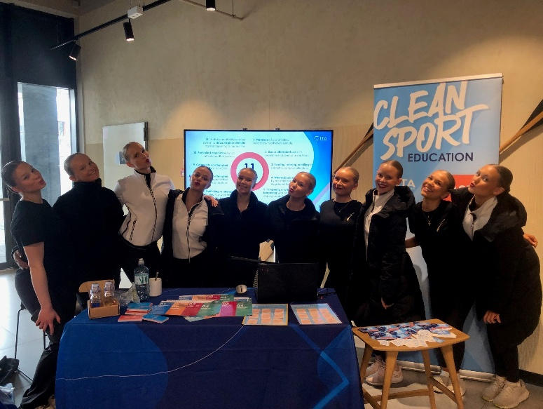

Unlike other events, many participants had not previously experienced doping control, making this early education particularly impactful. Athletes demonstrated high engagement, with teams dedicating significant time to both presentations and interactive learning tools.

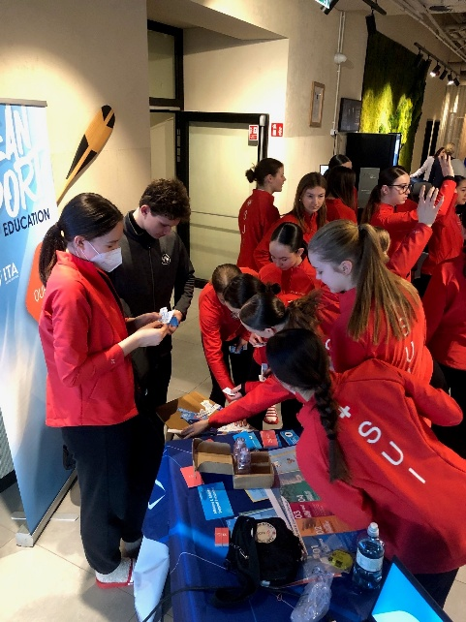
The initiative achieved a high overall success rating of 9/10 according to ITA’s own metrics reflecting strong engagement and the value of delivering structured education ahead of athletes’ first testing experiences.

Synchronized teams were given Pure As Ice goodies as usual to remind them of their commitment to clean sports and to stay “Pure as Ice.”

Overall Impact
Across both events, ISU’s Pure as Ice education continues to:
- Reach young athletes at key stages of their development
- Reinforce clean sport values through interactive learning
- Complement existing programmes such as Pure as Ice
- Strengthen athletes’ ability to make informed, responsible decisions
In short: small booths, big impact.

For further information about the ISU “Pure as Ice” initiative, visit the webpage here.

