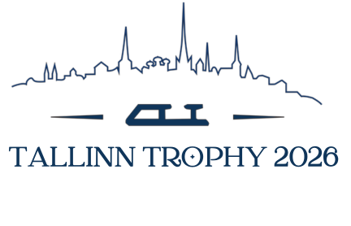

Tallinn, Estonia

November 16-22, 2026

ANNOUNCEMENT

Tallinn Trophy 2026

An International Junior Competition

for

Men, Women, Pair Skating, and Ice Dance

organized by

Estonian Skating Union, Tallinn Figure Skatin Club Union and Tallinn Figure Skating Scholl

Tallinn, Estonia

November 16-22, 2026

This competition is organized

under the authorization of the

International Skating Union

- GENERAL REGULATIONS

The Tallinn Trophy 2026 will be conducted in accordance with the ISU Constitution 2025, Competition & Event Regulations 2026, Sports Rules Single & Pair Skating and Ice Dance 2026, and the relevant ISU Communications.

Participation in the Tallinn Trophy 2026 is open to all Competitors who belong to an ISU Member, and qualify with regard to eligibility according to Competition & Event Regulations 2026, Article 7.2, provided their ages fall within the limits specified in Article 9.3.1, and they meet the participation, citizenship and residency requirement in Article 8 and ISU Communication 2526 or any update of this Communication.

In accordance with Article 8 and ISU Communication 2526, all Skaters who do not have the nationality of the Member by which they have been entered or who, although having such nationality, have in the past represented another Member, must produce an ISU Clearance Certificate. Passports of all Skaters, as well as the ISU Clearance Certificate, if applicable, must be presented at the accreditation of the event for verification.

All competitors must be entered through their respective ISU Member Federation.

- TECHNICAL DATA

PLACE | Main arena: Tondiraba Ice Rink, Varraku 14, Tallinn Estonia  (an indoor ice-rink with an ice surface of 30 x 60 m, air-conditioned and heated)  Practice arena: Tondiraba Ice Rink, Varraku 14, Tallinn Estonia  (an indoor ice-rink with an ice surface of 30 x 60 m, air-conditioned and heated)  Main and Practice Rinks are in the same complex building.

JUNIOR MEN | Short Program | The required elements to be skated are those listed in ISU Sports Rules Single & Pair Skating and Ice Dance 2026, Rule 611, paragraphs 1 and 2.  Duration: 2 min., 40 sec. +/- 10 sec.
 | Free Skating | In accordance with ISU Sports Rules Single & Pair Skating and Ice Dance 2026, Rule 612 and the respective ISU Communication. Special attention should be paid to the “well balanced program” and the element value.  Duration: 3 min., 30 sec. +/- 10 sec.
JUNIOR WOMEN | Short Program | The required elements to be skated are those listed in ISU Sports Rules Single & Pair Skating and Ice Dance 2026, Rule 611, paragraphs 1 and 2.  Duration: 2 min., 40 sec. +/- 10 sec.
 | Free Skating | In accordance with ISU Sports Rules Single & Pair Skating and Ice Dance 2026, Rule 612 and the respective ISU Communication. Special attention should be paid to the “well balanced program” and the element value.  Duration: 3 min., 30 sec. +/- 10 sec.
JUNIOR PAIRS | Short Program | The required elements to be skated are those listed in ISU Sports Rules Single & Pair Skating and Ice Dance 2026, Rule 620, paragraphs 1 and 2 for 2026/27.  Duration: 2 min., 40 sec. +/- 10 sec.
 | Free Skating | In accordance with ISU Sports Rules Single & Pair Skating and Ice Dance 2026, Rule 621 and the respective ISU Communication. Special attention should be paid to the “well balanced program” and the element value.  Duration: 3 min., 30 sec. +/- 10 sec.
JUNIOR ICE DANCE | Rhythm Dance | In accordance with ISU Sports Rules Single & Pair Skating and Ice Dance 2026, Rule 709.  Rhythms, required elements, and guidelines are those listed in ISU Communication 2795 and subsequent updates.  Duration: 2 min., 50 sec., +/- 10 sec
 | Free Dance | In accordance with ISU Sports Rules Single & Pair Skating and Ice Dance 2026, Rule 710. The required elements to be skated are those listed in ISU Communication 2795 and subsequent updates.  Duration: 3 min., 30 sec. +/- 10 sec.

- ENTRIES

4.1 General

All entries for the Tallinn Trophy 2026, must be done through the ISU Online Registration System (ORS) by the deadline indicated. Hotel and travel information should also be entered into ORS, as well as bank information. Declarations will need to be uploaded to the ORS as well.

4.2 Preliminary Entries

The preliminary entries must reach the Organizer by latest: October 1st, 2026 by entering the information through ORS.

4.3 Entries by Name

4.3.1 Entries of Competitors

Maximum 5 entries by discipline per Member, except the Host ISU Member.

The Entries by names must be made via the ISU Online Registration System (ORS):

https://fsk-ors.isu.swisstiming.com

and will be submitted via the ORS simultaneously to the:

Tallinn Trophy OC
Varraku 14
Tallinn
e-mail: info@tallinntrophy.eu

and to:

ISU Office
e-mail: entries@isu.org

not later than: Friday, October 16th, 2026 – 20:00 h (local time Tallinn).

4.3.2 Entries of Judges

Each participating ISU Member has the right to nominate one judge per discipline who has at least the qualification “Judge for International Competitions”.
In case of too many nominated judges, the organizer will draw the panel of judges immediately after the closing date for the entries. The result of such draw will be communicated to all ISU Members involved in writing immediately after the conclusion of such draw.
The Entries of Judges must be made via the ISU Online Registration System (ORS) not later than:
October 12th , 2026 – 20:00 h (local time Tallinn).

Each panel of Judges will consist of at least 7 Judges. In exceptional cases and if there is no possibility to compose a panel with at least 7 Judges, the ISU Vice-President Figure Skating may exceptionally authorize the panel in question to have a minimum of 6 Judges.
In case that at the time of the competition more Judges will be available and entered as required to compose the panels of Judges in one or more disciplines, the Organizing Member in consultation with the ISU will conduct on site, a draw for the panel of judges in the discipline in question for the first segment. The Judges, not drawn for the first segment will be seated for the second segment.

The panel for the second segment (Free Skating / Free Dance) will in this case be completed by an open draw amongst the Judges serving in the first segment of the discipline in question.

4.3.3 Entries of Team Members

Official entries of Team Leaders, Assistant Team Leaders, Team Officials, Team Medical Staff, Coaches and the partner or relative of a Judge will be accepted. Accreditation will be provided to those who are officially accepted by the Organizer.

Please be advised that only one Coach per Skater will be accredited. An Assistant Team Leader will be accepted for Teams having six (6) and more Skaters. Only two (2) Team Officials of each Member, including the Member President, provided that they are Council Members, Technical Committee Members or Members of the Head Office of their Federation, will be accredited. Not more than one (1) Team Doctor and one (1) Team Physiotherapist will be accepted as the Team Medical Staff, for which the organizer requests the right to have a medical certification (document) presented before accreditation. An accompanying person to a Judge will only be accepted for accreditation if this person is a partner in life or a relative of the Judge. The Member Federations guarantee that the requested accreditation of Team Members will correspond to their function within the team and the Federation.

The names of all team members must be submitted via the ISU Online Registration System (ORS) and must
reach the Organizing Committee and the ISU Office not later than:
October 30th, 2026 - 20:00 h (local time Tallinn).

4.4 Entry Fee

With the entry to the competition, the entry fee must be paid as follows:

115.00 € per single skater
150.00 € per pair or ice dance couple

The entry fee will not be refunded in case of withdrawals for any reason.

Payment instructions:
Bank Account information IBAN: EE261010220010907015
Bank Name: SEB Bank
Bank Address: Tornimäe 2, 15010 Tallinn, Estonia
BIC/Swift: EEUHEE2X
Holder’s Name: Tallinna Uisuklubide Liit MTÜ
Holder’s Address: Haabersti 3, Tallinn, 13513, Estonia

The deadline for entry fee payment is by October 16th, 2026. Failure to pay an entry fee in full by the deadline may result in removal from the entry lists. Any entry fee received after October 16th, 2026, is subject to late entry fee payment of 15 € per skater / couple.

- APPOINTED EVENT OFFICIAL

This International Figure Skating event will follow the requirements of CER Article 14.2.1, ISU Communication 2780 and principles of Rule 420, paragraph 5.a) of the ISU Sports Rules Single & Pair Skating and Ice Dance 2026 for appointing the Event Officials.

The members of each individual Technical Panel (Technical Controller and the Technical Specialists) will not be from the same ISU Member. At the members of the Technical Panel will have qualification of “International” or “ISU” level.

The Referee will have at least the qualification “International” and could be of the same ISU Member as one member of the Technical Panel (Technical Controller and Technical Specialists).

The Data Operator and the Replay Operator will have at least the qualification “International”.

- MEALS, LODGING AND TRAVEL EXPENSES

The organizer will provide and cover the expenses for rooms and meals for all Referees, the Technical Controllers, the Technical Specialists, the Data and Replay Operators and the Judges participating, depending on their appointed disciplines:

- Men: beginning with dinner on Tuesday, 17.11.2026 until breakfast on Friday, 20.11.2026.
- Women: beginning with dinner on Tuesday, 17.11.2026 until breakfast on Saturday, 21.11.2026
- Pairs: beginning with dinner on Tuesday, 17.11.2026 until breakfast on Saturday, 21.11.2026
- Ice Dance: beginning with dinner on Thursday, 19.11.2026, until breakfast on Monday, 23.11.2026

Should any of the above-mentioned persons arrive at the hotel before or stay longer than the period described above, their room costs and expenses will be the responsibility of the individual and must be paid on arrival.

The Organizing Committee will cover the costs for travel expenses for all Referees, the Technical Controllers, the Technical Specialists, and the Data and Replay Operators.

- PRACTICE

Official practice for Competitors begins on Tuesday, 17.11.2026. The detailed schedule will be issued at the time of registration.

- MUSIC / PLANNED PROGRAM CONTENT

In accordance with Rule 343 in the ISU Sports Rules Single & Pair Skating and Ice Dance 2026, the following method to submit the Competitor’s music to the Organizing Committee must be followed:

- the ISU Member is responsible for submitting their Competitor’s music as a direct attachment to an email to the Organizing Committee music@tallinntrophy.eu until November 10th, 2026 (one week prior to competition).
Please note: some music files might exceed the size of a regular email. In this case, an email-based transfer service that allows to send large files could be used to send the file to the OC.
- each submission shall be labelled with the name of the ISU Member, name of the category, segment, and the name(s) of the competitor(s):
Example:
GER_Men_SP_MUSTERMANN-Max
GER_Men_FS_MUSTERMANN-Max
SUI_Pairs_SP_MUSTERMANN-Erika_MUSTERMANN-Max
- the music files must be sent as WAV or MP3 file formats. Any other format is not acceptable.
Please note: Files in MP3 format may have a significant difference in the music quality when reproduced. The Organizing Committee in this case is not responsible if the music quality is insufficient.
- Each Competitor must have their own backup drive (USB Stick) for each program in the format of a WAV or MP3 file.
- The exact running time of the music (not skating time) must be communicated to the Organizing Committee when submitting the music and shall be certified by the Competitor/Coach/Team Leader at the time of registration.
- During the 1st Official Practice, the music will be played as indicated in the Practice Schedule and will allow to verify the correctness of the submitted music. If there is an issue with the music, the Team Leader/Coach may be allowed to change the music by presenting an acceptable reproduction to the Organizing Committee’s Music Team (USB Stick with file format of WAV or MP3 file).
If the music files have been submitted within the above-mentioned deadline to the Organizing Committee, then the music team of the Organizing Committee is entirely responsible for the correct execution of the music. In case of issues with submitted music files, the Organizing Committee may request, at the time of registration, a secondary copy of the music files. In case the music files have not been submitted in time to the Organizing Committee, the skater(s) must present their music at the latest at the time of registration on the above-mentioned means and in the defined format.

Please note: CDs will not be accepted by the Organizing Committee.

ISU Members/Skaters are reminded that, for them to use music to accompany their routines, the following ‘Music Accompaniment’ rights/licenses are required:
- the right to edit or adapt music into a mix, if more than one song is being used.
- the right to set choreography to the music, often referred to as a ‘Grand Right’, which is the right to perform musical compositions and recordings within the context of a "dramatic work” or choreography.
- the right to create any copies of the music that may be needed for training and competition purposes, also known as the ‘mechanical rights’.

For a music to be fully cleared for these uses, these rights need to be cleared for each and every track used in each mix that contains a license (backed by a warranty and legal indemnity) for appropriate territory(s) that covers both the master rights of the recording artist and the publishing rights of each individual writer and composer of the track.

If music information is not complete and/or the music is not provided, accreditation will not be given.

The Planned Program Content must also be entered by the ISU Member or the Skater(s) on the dedicated ISU platform. It is mandatory that the Program Content information be filled in precisely by each Skater/team in English using the terminology for the elements listed in the respective ISU Communication.

- ARRIVAL OF PARTICIPANTS / TEAMS

The nearest airport to Tallinn is Tallinn Lennart Meri Airport (TLL) with a distance of 4 km to the official hotel.

The Organizing Committee does not provide a shuttle bus to meet the teams on arrival. Teams can use public transportation means or taxi. One time ticket price is 2 EUR, QR code ticket can be purchased on https://tallinn.pilet.ee/ portal at the date of arrival.

All Referees, the Technical Panel (Technical Controllers, Technical Specialists, Data & Replay Operators), Judges, Competitors, Team Leaders, Team Officials, Team Medical Staff and Coaches are requested to announce to the Organizing Committee as soon as possible but no later than November 1st, 2026 the name of the airlines, flight numbers, dates and times of arrival or any other information concerning transportation and arrivals. The detailed travel information needs to be submitted via the ISU Online Registration System (ORS).

- OFFICIAL HOTEL(S)

RADISSON BLU OLÜMPIA HOTEL
📍Liivalaia 33, 10118 Tallinn, Estonia
email: estonia.events@radissonblu.com
Special Rate:
Single Room 93 EUR/night including breakfast, spa and gym access
Twin/Double Room 109 EUR/night including breakfast, spa and gym access

For booking, please contact estonia.events@radissonblu.com with code word
“ISU CS Tallinn Trophy 2026”. Special Rates are subject to availability.

PARK INN BY RADISSON CENTRAL
📍Narva mnt 7c, 10117, Tallinn, Estonia
email: estonia.events@radissonblu.com
Special Rates:
Single Room 72 EUR/night including breakfast and gym access
Twin/Double Room 82 EUR/night including breakfast and gym access
Triple Room 108 EUR/night including breakfast and gym access

For booking, please contact estonia.events@radissonblu.com with code word
“ISU CS Tallinn Trophy 2026”. Special Rates are subject to availability.

ORU HUB HOTEL TALLINN
📍Narva mnt 120, 10127, Tallinn, Estonia
email: Cathi.KOKK@accor.com
Special Rates:
Single Room 60 EUR/night including breakfast
Double Room 65 EUR/night including breakfast

For booking, please contact Cathi.KOKK@accor.com with code word
“TROPHY”. Special Rates are subject to availability.

HAMPTON BY HILTON TALLINN
📍Tartu mnt 49, 10115, Tallinn, Estonia
Special Rates:
Single Room 70 EUR/night including breakfast and gym access
Double Room 75 EUR/night including breakfast and gym access

For booking, please contact sales@hamptontallinn.com with code word
“Tallinn Trophy 2026”. Special Rates are subject to availability.

- ACCREDITATION

The official accreditation for Teams is planned at the Tondiraba Ice Hall upon arrival.

Accreditation as a Team Member will be given to all entered Judges, Competitors, and one Team Leader per participating team, one Coach per Competitor, a maximum of two Team Officials of ISU Members (including the Member President), provided that they are Council Members, Technical Committee Members or Members of the Head Office of their Federation, and a maximum of two medical persons. Accreditation will only be granted to persons in those various functions if officially entered and named through their ISU Member. The ISU Member certifies with the signed entry form the indicated functions within the team of all team members. Any misuse of any function will be sanctioned by the ISU/OC.

Accreditation will be given to appointed Event Officials and Guests.

Chaperons will not receive accreditation. The Team Leader may request “bus permits” for the officially registered Chaperons to join the official shuttle bus system of the Organizing Committee.
- RESULTS

The marking system (ISU Judging System) as described in ISU Sports Rules Single & Pair Skating and Ice Dance 2026, Rule 352 and Rule 353 be used.

- PRESENTATION OF MEDALS AND PRIZES

The three best placed Skaters/Couples in each event will be announced and honored. Gold, silver and bronze medals will be presented to the medalists. The national anthem of the winner will be played and the flags of the medal winners hoisted.

- INSURANCE / LIABILITY

In accordance with Article 17.3, it is the sole obligation of each Member participating in ISU Events, to provide medical and accident insurance for their athletes, officials and all other members of the Member’s team. Such insurance must assure full medical attendance and also the return of the ill or injured person to the home country by air transport or by other expeditious. It is an internal matter of each ISU Member to decide the issue who shall pay the premium for such insurance.

The ISU and the Organizing Committee assume no responsibility for or liability with respect to bodily or personal injury or property damage incurred incurred by Competitors or Officials in connection with the event.

- EXHIBITION

There will be no exhibition held at the Tallinn Trophy 2026.

- MEETINGS FOR ISU EVENT OFFICIALS AND JUDGES

All Referees, Technical Controllers, Technical Specialists, Data and Replay Operators and Judges are responsible to make their travel arrangements in order to be able to attend the respective event related meetings. If any other party makes the flight arrangements, the Referees, Technical Controllers, Technical Specialists, Data and Replay Operators and the Judges are responsible to check if such arrangements are in line with the detailed schedule as mentioned under paragraph 18.

- INFORMATION AND VARIOUS

For information, please contact the Organizing Committee:

Tallinn Trophy OC
Varraku 14
Tallinn
e-mail: info@tallinntrophy.eu

To stay up to date with information, possible restrictions and the latest updates please follow competition on Sportity App (iOS/Apple and Android) using code: CSEST2026.

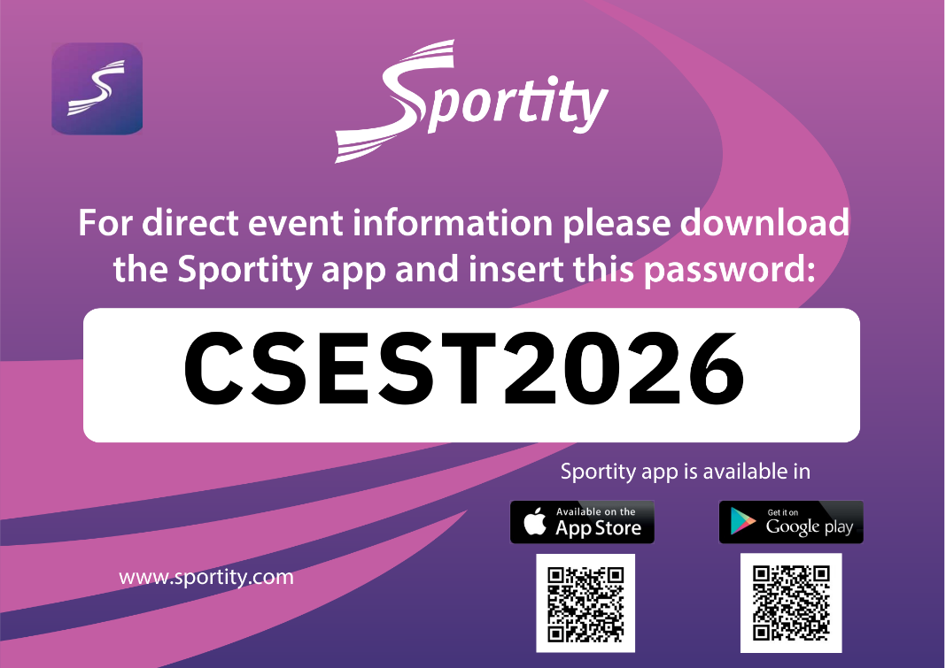

FORMS AND DEADLINES

Number | Form | Format | Deadline
N/A | Preliminary Entry Form | ORS | 01.10.2026
N/A | Composition of Delegation | ORS | 30.10.2026
N/A | Entry Form for Competitors | ORS | 16.10.2026
N/A | Entry Form for Judges | ORS | 12.10.2026
N/A | Team Travel Form | ORS | 01.11.2026
N/A | Press Information | ISU Portal | Valid for season 26/27
N/A | Competition Music Information | ISU Portal | Valid for season 26/27
N/A | Ice Dance Music Information | ISU Portal | Valid for season 26/27
N/A | Program Content Form | ISU Portal | Valid for season 26/27

